PROGRAMINIG FUNDAMENTLA (01.03.2026)

Class note
https://docs.google.com/document/d/129NVo_l1oP-Gdn1GUqMxQCyubDhCsnc97e8CGHoHQmA/edit?usp=sharing

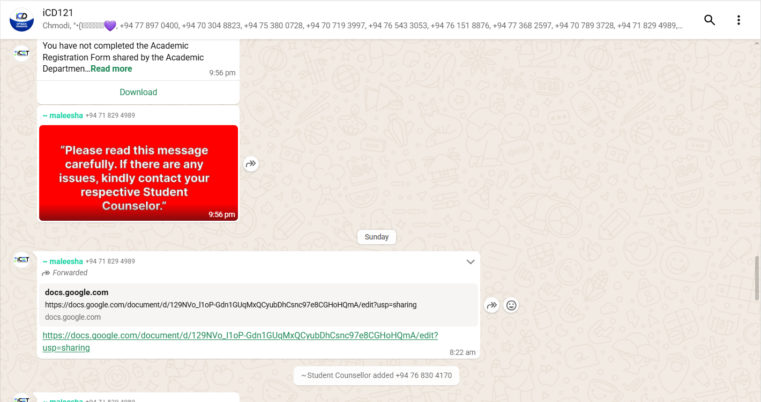

{} curly bracts
[] secure bracts
() parentheses

- Note pade eka open karanne working folder eke(Open the folder, go to the taskbar, and type CMD, and then press enter)
- CMD(terminal) eke type karanna notepad Example.java (note pade eken example.java namin sourse file ekak hadanna kiyala)
- Itapasse enter karama note pade eka open wenawa.
- Note-pade eke type karanna. Ita passe aniwaryayen save karanna
Class Examle{
Public static void main(String[] args){
System.out.println(“Hello World!”);
}
}

- Ita passe CMD eke javac Example.java kiyala type karala compile karanna mulinma
- Onama comand ekak compile karakarala thamai run karanna ona.
- Compile karata passe run karann file eka
- Folder eke aluthen apu example jawa file eka byte code eka
- Main method
public static void main(String args[]){
System.out.println("A");
System.out.println("B");
System.out.println("C");
System.out.println("D");
System.out.println("E");
}
- Block comments
class Example{
public static void main(String[] args){
System.out.println("A");
/*System.out.println("B");
System.out.println("C");
System.out.println("D");
System.out.println("E");*/
System.out.println("F");
}
}
- Line comments
class Example{
public static void main(String[] args){
System.out.println("A");
//System.out.println("B");
//System.out.println("C");
//System.out.println("D");
System.out.println("E");
System.out.println("F");
}
}

- Document comments
/**
This main method
*
public static void main(String[] args){
System.out.println("A");
/*System.out.println("B");
System.out.println("C");
System.out.println("D");
System.out.println("E");*/
System.out.println("F");
}
}

- Class name eka wenas unata compile wenawa. Class name eka wenas wenna puluwan. Compile error enne na, runtime error na. class name eka naming byte code eka hadenne(Ex- byte codde name is Githmi). Source code eka naminma byte code eka awashaya na.public dammoth witharai ekama naming ona.

class Githmi{
public static void main(String[] args){
System.out.println("A");
/*System.out.println("B");
System.out.println("C");
System.out.println("D");
System.out.println("E");*/
System.out.println("F");
}
}

JAVA LITTERUS
- System.out.println("F"); F yanu litter ekak wei

INTEGER LITERALS
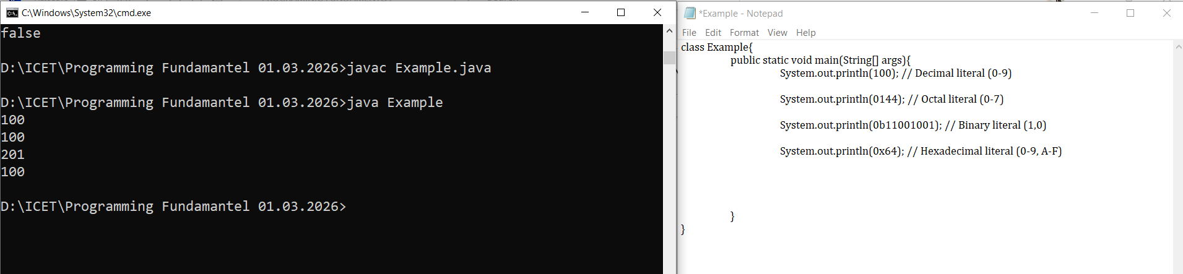
- Specially me part eka aye balanna (INTEGER LITERALS)

FLOTING POINTS LITERALS

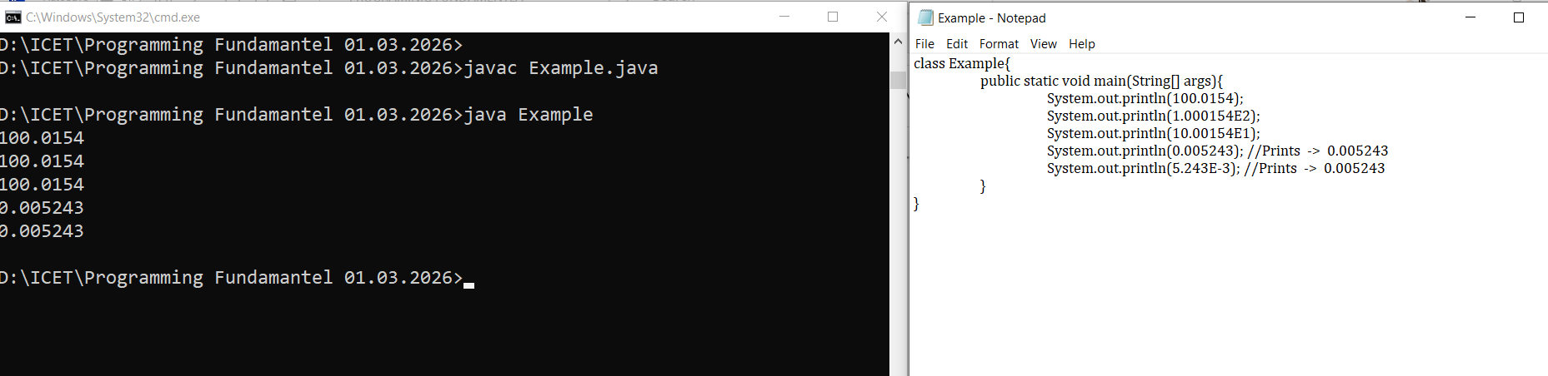

CHARACTER LITERALS
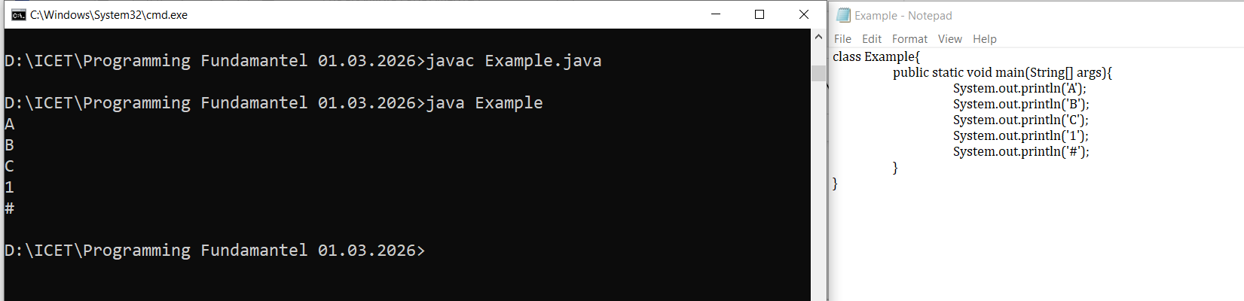

- ‘AB’ kiyala character 2k ekata dana ba.
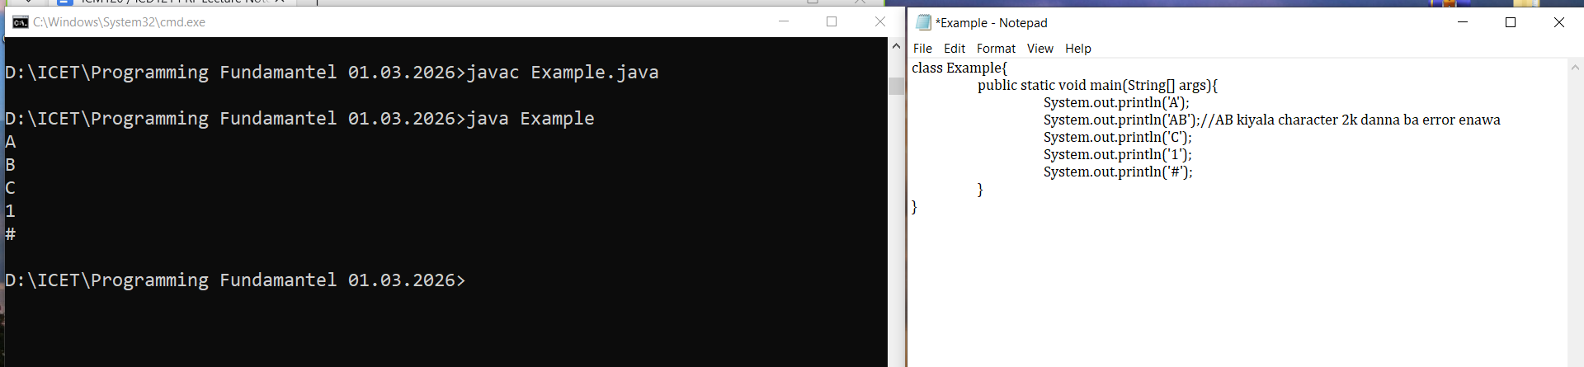

- Backspace (‘\b’)
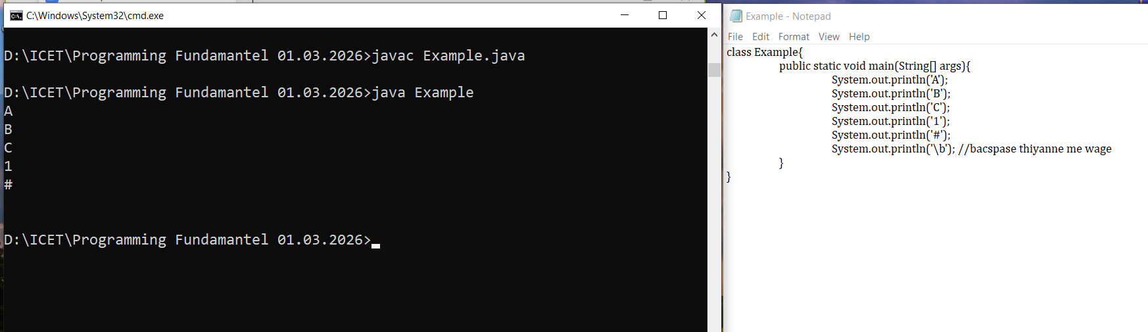

Backspace eken wenne apassata curser eka ena ekane.
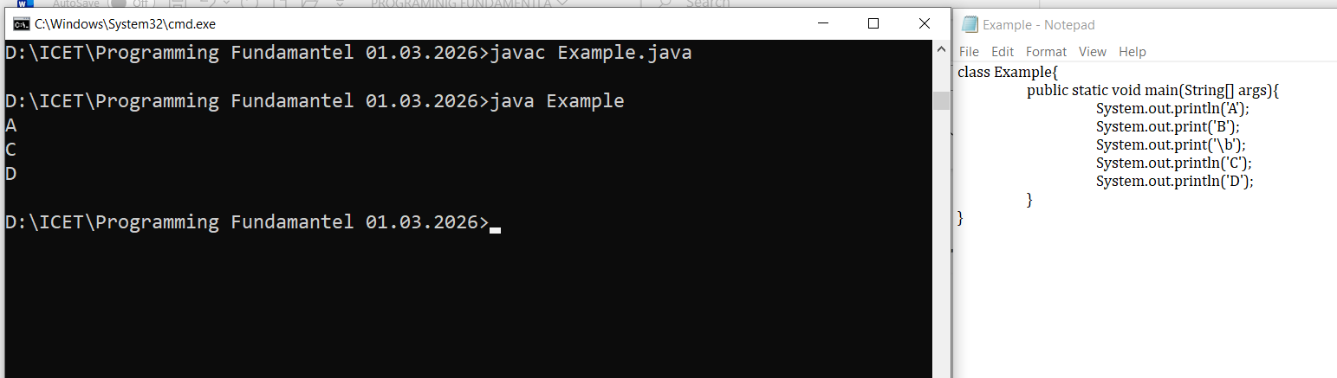
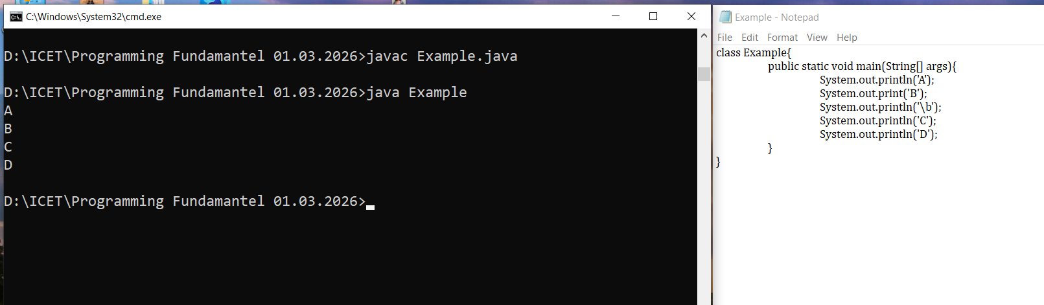

- Sirge ss walin Q46 balanna backspace eka gana thiyna
(\t,\n\r) me tika try karanan
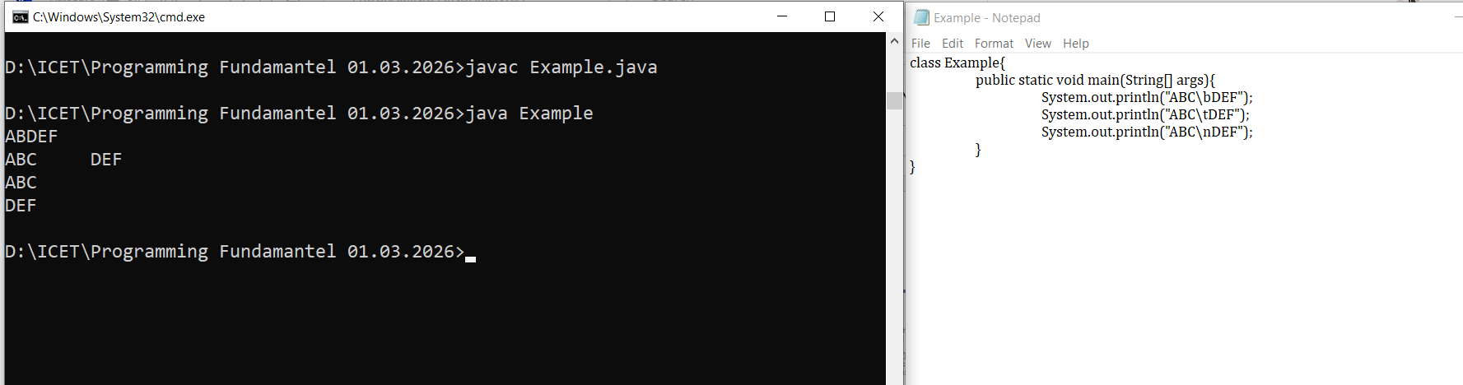

“//’ BACKWOED SLAWSH & “/” FORWORD SLASH
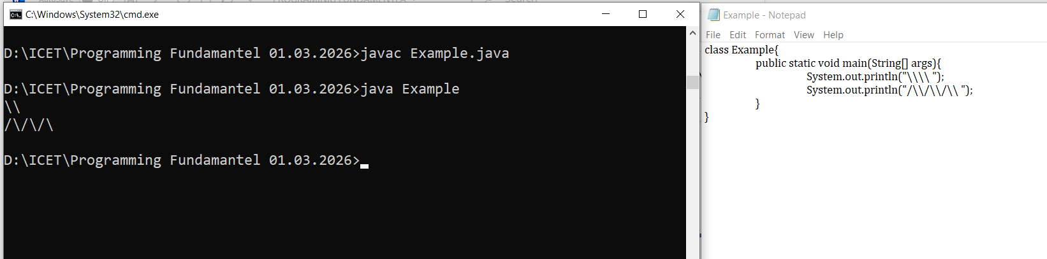
- \\ 2k dann onam 4k dann ona(\\\\ backwoed 4k dann ona)
- /\ forword slawsh(/) 1i backwordslawsh(\\) 2k danna ona

- ( “” )
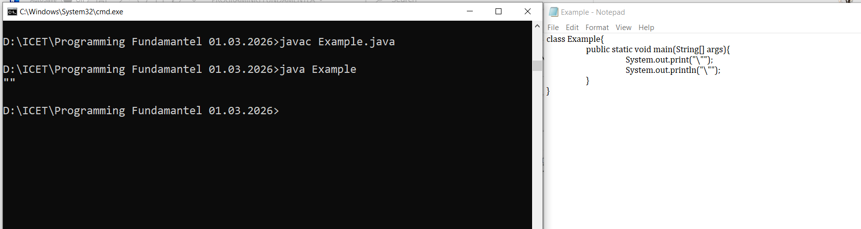

STRING LITERALS

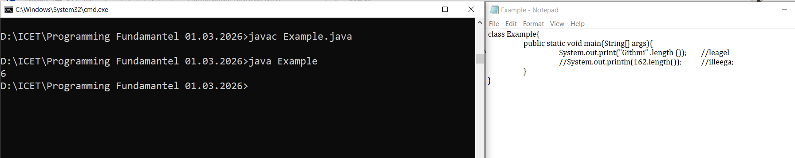

VARIABLE
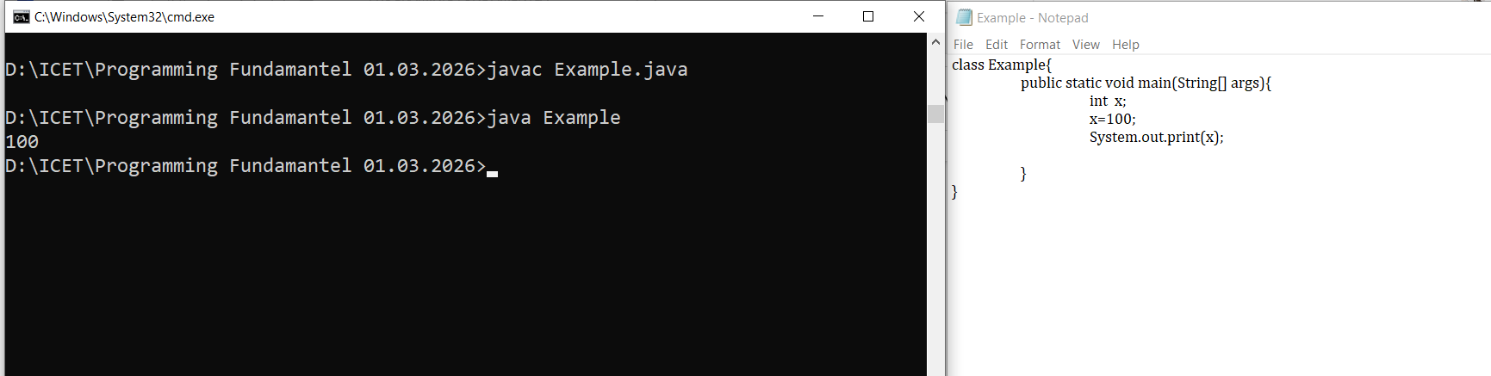
- Anthimata assign karapu eka thama print wenne
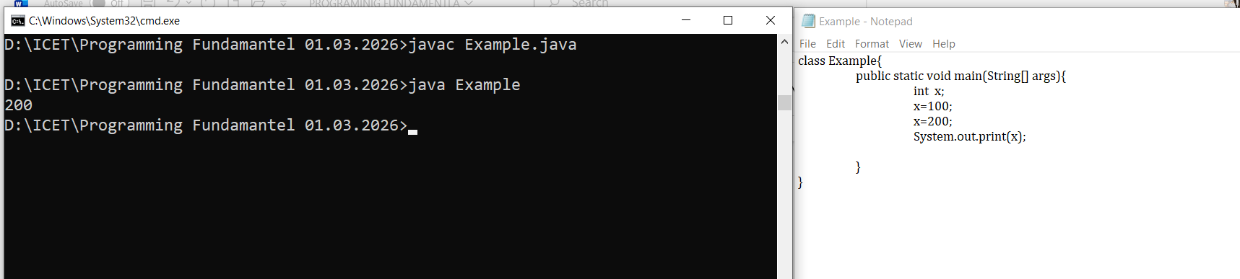
String Concatenation And Arithmetic Addition

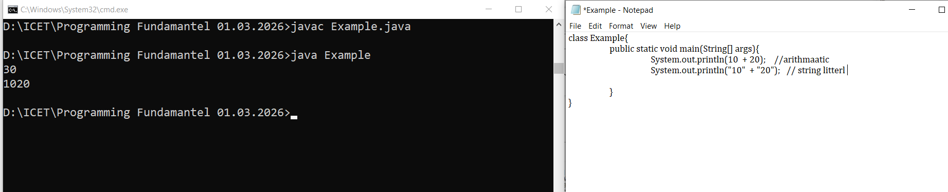

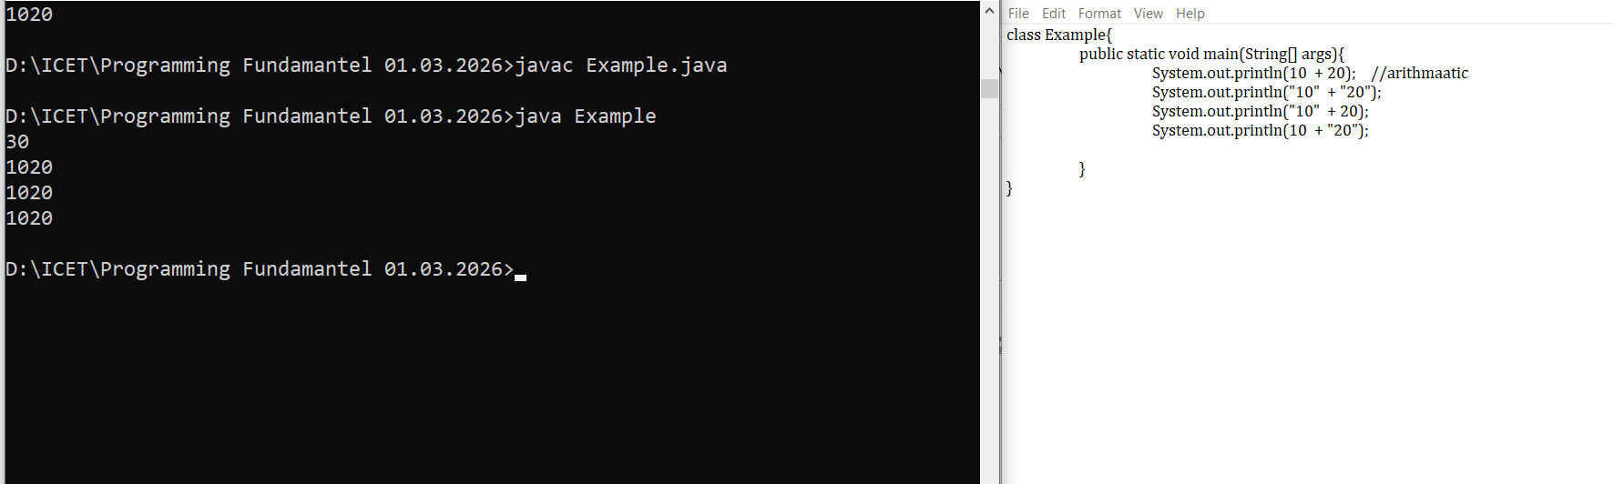

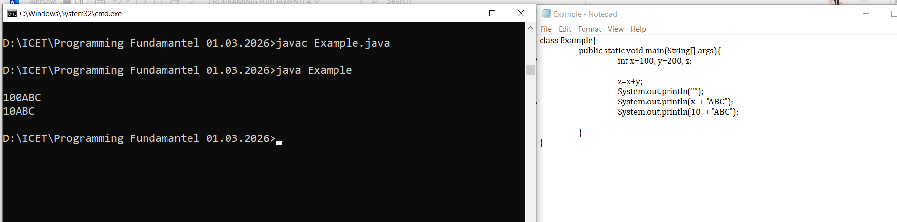
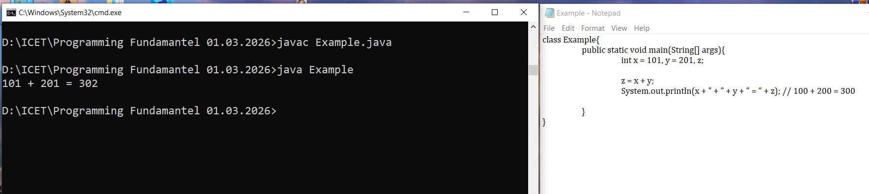

USER INPUT
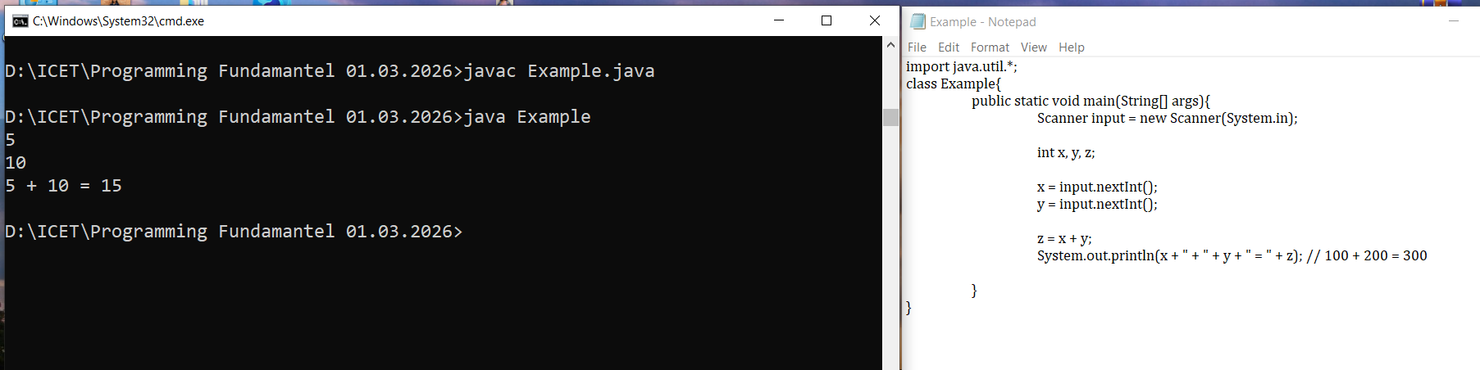

ASSIGNMENT

- Open the folder, go to the taskbar, and type cmd, and then press enter.

